SCHEDULING

Given the list of processes, their CPU burst times, arrival times. Implement FCFS, SJF process scheduling algorithms on the processes.

**Waiting time:** Processes need to wait in the process queue before execution starts and in execution while get preempted.

**Turnaround time:** Time elapsed by each process to get completely served. (Difference between submission time and completion time).

**FCFS Scheduling:**

Here the processes are arranged in order of their increasing arrival time. Check for incoming processes after the completion of the current process.

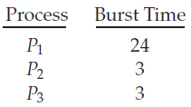

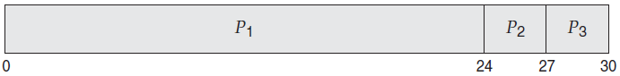

**Sample Input and Output:**

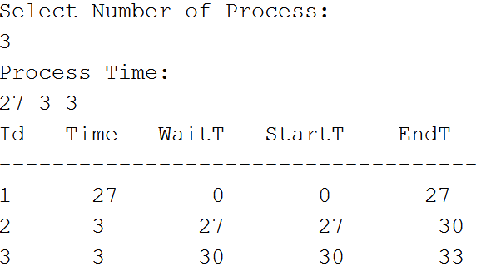

**SJF Scheduling:**

Check for incoming processes after every time step (1 ms).

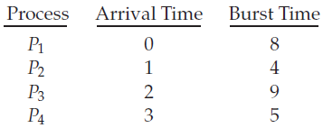

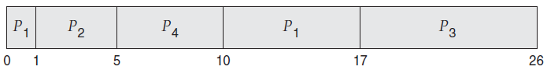

You have to use the Same Skeleton Code given for FCFS Scheduling but you have to sort the process according to its Time .